Document for MOBILE AUTOMATION

I) Environment Specifications:

- Selenium IDE : A Firefox plug-in which deals with and playback mechanism. User can create simple scripts and export to selenium Webdriver.

- Selenium Webdriver : (Supports all major browsers, we use Mozilla, chrome and IE)
Selenium is a well know open source testing framework, which is widely used for testing Web-based applications.
Webdriver was developed to better support dynamic web pages like Ajax where elements of a page may change without the page itself being reloaded.

- Eclipse IDE :
Eclipse is an integrated development environment (IDE)

- Java :
Step 1: Install the Java Development Kit (JDK) -> jdk-8u45-windows-x64.exe
Step 2: Set Up Java Environment Variable Path

- JUnit :
JUnit is a unit testing framework for Java programming language. It plays a crucial role test-driven development, and is a family of unit testing frameworks collectively known as xUnit.
JUnit promotes the idea of "first testing then coding", which emphasizes on setting up the test data for a piece of code that can be tested first and then implemented. This approach is like "test a little, code a little, test a little, code a little." It increases the productivity of the programmer and the stability of program code, which in turn reduces the stress on the programmer and the time spent on debugging.

Features of JUnit:
- JUnit is an open source framework, which is used for writing and running tests.
- JUnit tests allow you to write codes faster, which increases quality.
- JUnit is elegantly simple. It is less complex and takes less time.
- JUnit tests can be run automatically and they check their own results and provide immediate feedback. There's no need to manually comb through a report of test results.
- JUnit tests can be organized into test suites containing test cases and even other test suites.
- JUnit shows test progress in a bar that is green if the test is running smoothly, and it turns red when a test fails

6. Log4j framework:
It helps us collect information about how the application is running and also helps us debug if any failure occurs.
- Log4j allows you to have a very good logging infrastructure without putting in any efforts.
- Log4j gives you the ability to categorize logs at different levels (Trace, Debug, Info, Warn, Error and Fatal)
- Log4j gives you the ability to direct logs to different outputs. For e.g. to a file, Console or a Database.
- Log4j gives you the ability to define the format of output logs.
- Log4j gives you the ability to write Asynchronous logs which helps to increase the performance of the application.

- Cucumber :
Cucumber is one such open source tool, which supports behavior driven development. To be more precise, cucumber can be defined as a testing framework, driven by plain English text. It serves as documentation, automated tests, and a development aid – all in one.

So what does Cucumber do? It can be described in the following steps −
1. Cucumber reads the code written in plain English text (Language Gherkin) in the feature file.
2. It finds the exact match of each step in the step definition (a code file).

The piece of code to be executed can be different software frameworks like Selenium, Ruby on Rails, etc. Not every BDD framework tool supports every tool.
This has become the reason for Cucumber's popularity over other frameworks, like JBehave, JDave, Easyb, etc.
Cucumber supports over a dozen different software platforms like −
- Ruby on Rails
- Selenium
- PicoContainer
- Spring Framework

Advantages of Cucumber Over Other Tools :
- Cucumber supports different languages like Java.net and Ruby.
- It acts as a bridge between the business and technical language. We can accomplish this by creating a test case in plain English text.
- It allows the test script to be written without knowledge of any code, it allows the involvement of non-programmers as well.
- It serves the purpose of end-to-end test framework unlike other tools.
- Due to simple test script architecture, Cucumber provides code reusability.

- File Formats Used in the Framework :
Properties file – We use properties file to store and retrieve the UI elements of an application or a website and data set file paths.

---------------------------------------------------------------

II) Installation on Windows:

Step 1: Install the Java Development Kit (JDK)
Install the Java Development Kit (JDK) -> jdk-8u45-windows-x64.exe

Step 2: Set Up Java Environment Variable Path
JAVA_HOME=C:\Program Files\Java\jdk1.8.0_45
PATH = %JAVA_HOME%\bin;

Step 3: Install Android SDK / ADB on Windows
Android Requirements:
Android SDK API >= 17 (Additional features require 18/19)
Appium supports Android on OS X, Linux and Windows.
Intel HAXM is installed.

Step 4: Set up Android Environment Variable
ANDROID_HOME=C:\Users\stpl\AppData\Local\Android\android-sdk
PATH = %ANDROID_HOME%\platform-tools

Step 5: Download and Install NodeJs
https://nodejs.org/en/download/

Step 6: Install Microsoft .net Framework : .NET Framerork 4.5
https://www.microsoft.com/en-in/download/details.aspx?id=30653

Step 7: Install Appium through command line
1. Open command prompt(cmd).
2. Type these commands:
npm install -g appium@1.6.0 and press enter. (We have to install specific appium version)

Step 8: Enabling Developer Mode Options on Android Phone or Tablet (v4.2 or higher)
1. Click Menu button to enter into App drawer.
2. Go to "Settings".
3. Scroll down to the bottom and tap "About phone" or "About tablet",
4. Scroll down to the bottom of the "About phone" and locate the "Build Number" field.
5. Tap the Build number field seven times to enable Developer Options. Tap a few times and you'll see a countdown that reads "You are now 3 steps away from being a developer."
6. When you are done, you'll see the message "You are now a developer!".
7. Tap the Back button and you'll see the Developer options menu under System on your Settings screen.

Now, you can enable USB Debugging mode.
8. Go to Settings>Developer Options>USB Debugging. Tap the USB Debugging checkbox.
Step 9: Download and Install PdaNet to Connect with Android Device
http://pdanet.co/a/

Step 10: Install Eclipse IDE And set up a project

----------------------------------------------------------------------
III) Set-up Android Development Tools (ADT) Plug-in in Eclipse:
This step will help you in setting Android Development Tool plug-in for Eclipse. Let's start with launching Eclipse and then, choose Help > Software Updates > Install New Software. This will display the following dialogue box.
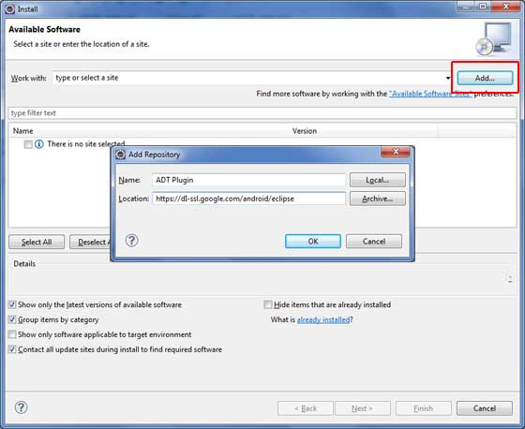
Now use Add button to add ADT Plug-in as name and https://dl-ssl.google.com/android/eclipse/ as the location. Then click OK to add this location, as soon as you will click OK button to add this location, Eclipse starts searching for the plug-in available the given location and finally lists down the found plug-ins.
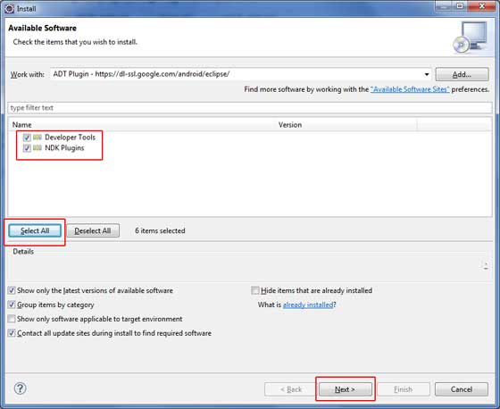

Now select all the listed plug-ins using Select All button and click Next button which will guide you ahead to install Android Development Tools and other required plug-ins.
Step 11: Set Up Appium Project in Eclipse
Step 12: Create Emulator in Eclipse
1. Click Android Virtual Device (AVD) Manager
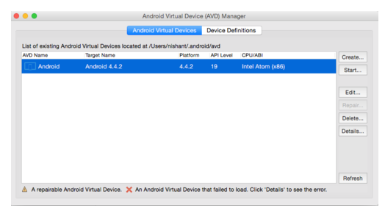
2. Click Create
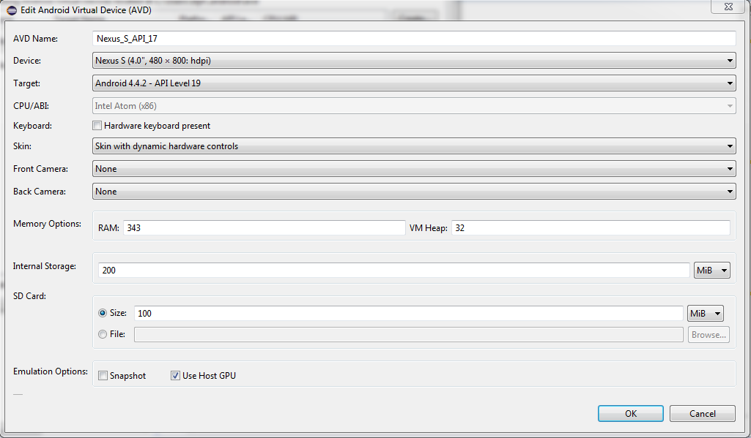
Click OK

3. Select created device > Start > Launch
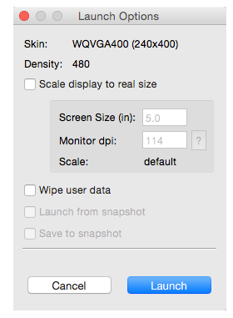

NOTE : FOR STEP 12, we can also use Genymotion emulator.
- Install genymotion-2.4.0-vbox.
- Update genymotion if asked.
- Make an account on it so that virtual devices can be created.
- Click on Settings --> Click on ADB --> set custom Android sdk path. (same as u had set for ANDROID_HOME variable, i.e. C:\Users\stpl\AppData\Local\Android\android-sdk)
- Create a virtual device by clicking on “ADD”.
- After creating it, start virtual device.

To check if emulator is in active(online) state, go to C:\Users\stpl\AppData\Local\Android\android-sdk\platform-tools and on top where whole path is displayed, click on it and type cmd.

Now type: adb devices

It will display like this -

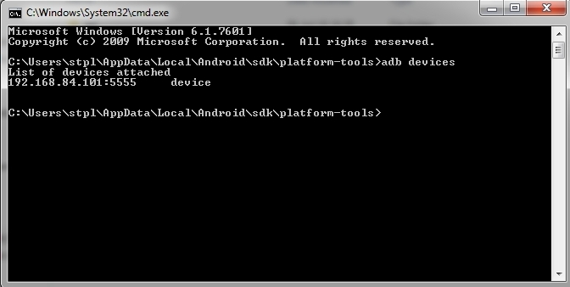

LIST OF DEVICES ATTACHED displays - ‘device name’ and its ‘state’ - where ‘device’ specifies device is active(online).

For connected but inactive devices it displays ‘offline’.

For devices which are not connected, nothing is displayed in list of devices attached.

Like for above screenshot example - device name is “192.168.84.101:5555” and its active specified by “device” in front of device name.

----------------------------------------------------------------------

IV) Behavior Driven Development (BDD)
1. In order to get better advantage of the software testing, organizations are nowadays taking a step forward. They implement important acceptance test scenarios while development is in-progress. This approach is commonly known as Behavior Driven Development (BDD).

2. Behavior Driven Development gives us an opportunity to create test scripts from both the developer’s and the customer’s prospective as well. So in the beginning, developers, project managers, QAs, user acceptance testers and the product owner (stockholder), all get together and brainstorm about which test scenarios should be passed in order to call this software/application successful. This way they come up with a set of test scenarios. All these test scripts are in simple English language, so it serves the purpose of documentation also.

3. Example-
If we are developing a user authentication feature, then the following can be few key test scenarios, which needs to get passed in order to call it a success.

The user should be able to login with correct username and correct password.
The user should not be able to login with incorrect username and correct password.
The user should not be able to login with correct username and incorrect password.

4. How it Works
By the time the code is ready, test scripts are ready too. The code has to pass the test scripts defined in BDD. If it does not happen, code refactoring will be needed. Code gets freezed only after successful execution of defined test scripts.
It is a very simple notion, but what we need in order to get this concept implemented. The answer is, Behavior Driven Development (BDD) Framework. Cucumber is one such open source tool, which supports behavior driven development.

5. Behavior-driven development is about collaboration & communication

6. Behavior-Driven Development is a tool to aid collaboration and start a conversation between the two departments. It’s also a way to clarify the scope of a desired feature and get better estimates from the dev team.

7. Conclusion -
Describing and understanding the needs of a system has a ton of benefits beyond code correctness: establishing inter-departmental dialog and making sure all stakeholders’ concerns are met (and not just the stakeholders with big fancy titles). Using behavior-driven development to understand these needs from the start and testing external business behaviors that the entire team cares about—that is a great way to ensure a quality project.

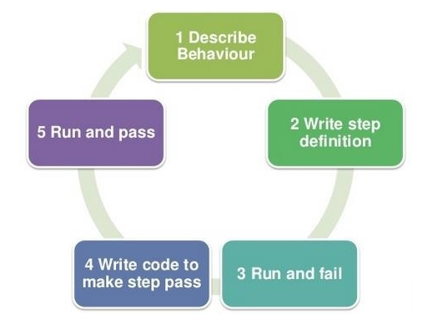
----> First we create feature file (decribing behaviour) and corresponding to it we write Step Definitions (glue code). We also find locators for elements and store them separately.
---> Then we write code to make steps pass.
---> Finally run and pass.

----------------------------------------------------------------------
V) Page Object Model
Page Object model is an object design pattern in Selenium, where web pages are represented as classes, and the various elements on the page are defined as variables on the class. All possible user interactions can then be implemented as methods on the class.

Page Object Model introduces an abstraction layer within your Selenium tests and it provides a programmatic API to drive and interact with a UI. It makes automation easily readable and maintainable. Each page of your AUT (Application Under Test) is mapped to a class file in your code and each method within the class file can be treated as a service offered by the Page Object.
To design a Page Object, first we need to understand that a page can typically be divided in functional or in structural manner.

Advantages of POM
- Page Object Pattern says operations and flows in the UI should be separated from verification. This concept makes our code cleaner and easy to understand.
- Second benefit is the object repository is independent of test cases, so we can use the same object repository for a different purpose with different tools. For example, we can integrate POM with TestNG/JUnit for functional testing and at the same time with JBehave/Cucumber for acceptance testing.
- Code becomes less and optimized because of the reusable page methods in the POM classes.
- Methods get more realistic names which can be easily mapped with the operation happening in UI. i.e. if after clicking on the button we land on the home page, the method name will be like 'gotoHomePage()'.

Example :

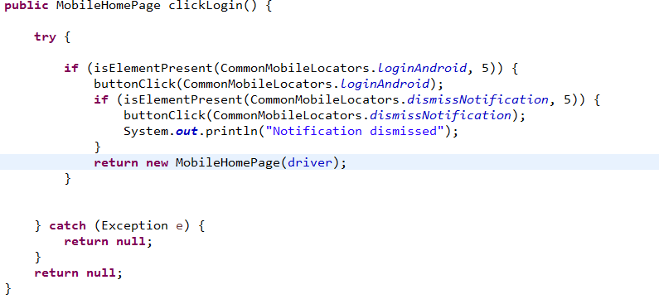
----------------------------------------------------------------------
VI) Flow And Structure of our Maven Project in Eclipse IDE

- Basic structure of our Maven project -

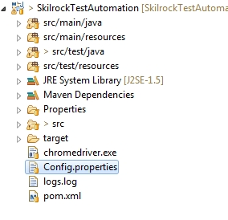

2. Feature Files - in src/test/resources

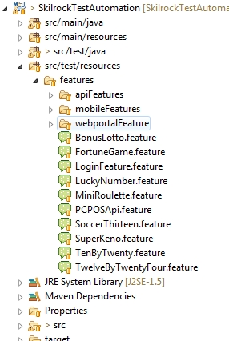

Feature File example-
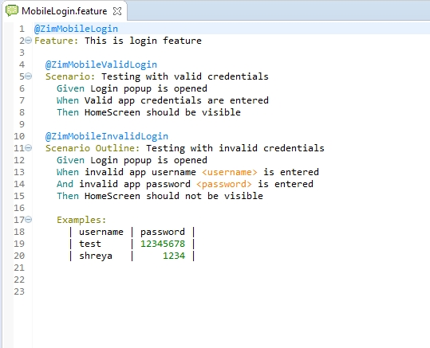

3. Locators files - in src/main/java/objectRepository

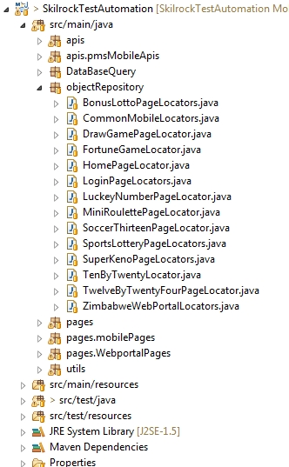

Locators file Example-

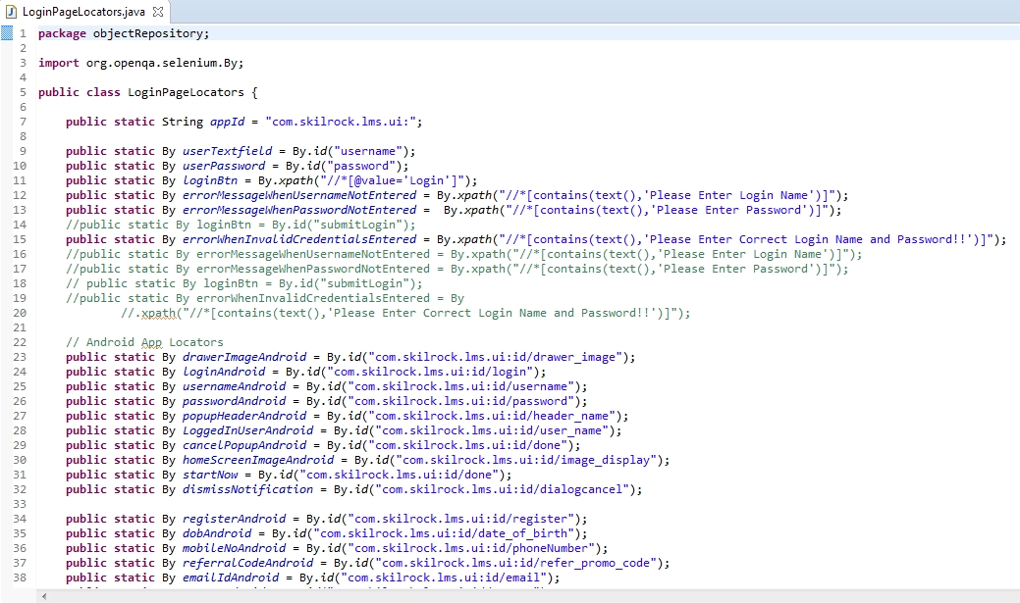

4. Step Definitions - in src/test/java/stepDefinitions

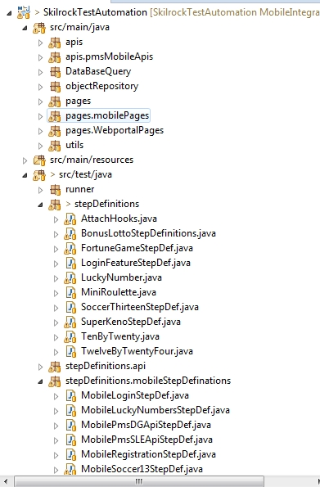

Step Definitions Example -

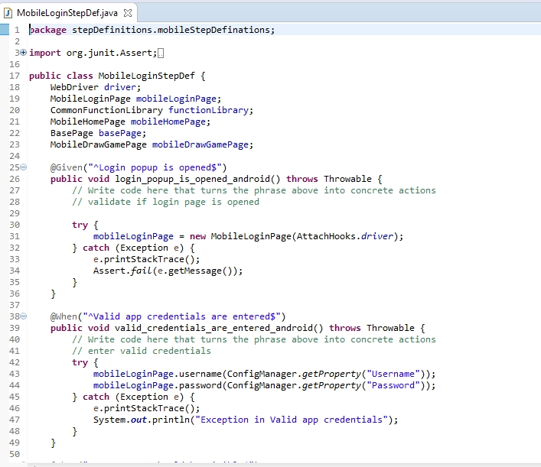

- Code - in src/main/java/pages

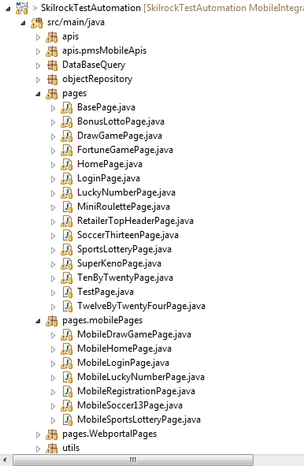
Code Example-

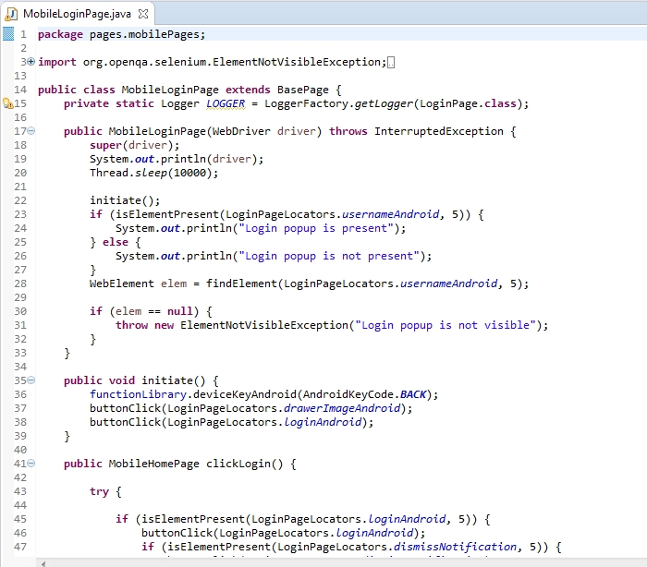

- RunTest file - in src/test/java/runner ( to run whole test suite using tags)

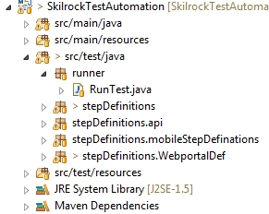

Create a Junit runner to run the test.
@CucumberOptions are like property file or settings for test.
Basically they enables us to do all the things that we could have done if we have used cucumber command line.
Reports : Path of the report is provided as given here. The reports will be generated as “cucumberreports.json” when project is run from Jenkins server and “pretty” format specifies the type of report.

Pretty: Prints the Gherkin source with additional colors and stack traces for errors. Use below code:
format = {“pretty“}

JSON: This report contains all the information from the gherkin source in JSON Format. This report is meant to be post-processed into another visual format by 3rd party tools such as Cucumber Jenkins. Use the below code:
format = {“json:Folder_Name/cucumber.json“}

glue : It is almost the same think as Features Option but the only difference is that it helps Cucumber to locate the Step Definition file. Whenever Cucumber encounters a Step, it looks for a Step Definition inside all the files present in the folder mentioned in Glue Option. It can be specified like:
glue = “stepDefinition“
Or if the Step Definition file is in the deep folder structure
glue = “src/test/stepDeinition“

Features : Features Options helps Cucumber to locate the Feature file in the project folder structure.

tags : Instruct what tags in feature file should be executed.

Monochrome : This option can either set as true or false. If it is set as true, it means that the console output for the Cucumber test are much more readable. And if it is set as false, then the console output is not as readable as it should be.

